**Name – Jyoti Sahebrao Jagtap**

**Email –** [**jyotishinge60@gmail.com**](mailto:jyotishinge60@gmail.com)

• **Introducing to Cmdlets** – Cmdlets are small, built-in PowerShell commands that perform a single, specific function. They follow a Verb-Noun naming pattern (e.g., Get-Process). Cmdlets are more powerful than traditional commands because they return objects, not plain text.

• **The PowerShell Pipeline** – The pipeline connects multiple commands so that the output of one becomes the input of the next. This allows you to process data step-by-step without storing intermediate results. It helps in creating clean, readable, and efficient commands.

• **Key Cmdlets** – These are the most frequently used commands in PowerShell, such as Get-Help (learn about commands), Get-Command (list available commands), and Get-Service (view services). Learning them speeds up your PowerShell skills.

• **WMI & PowerShell** – WMI (Windows Management Instrumentation) lets you query and control system settings and information. In PowerShell, WMI can be accessed using cmdlets like Get-WmiObject or Get-CimInstance for tasks like checking hardware details or managing services.

• **Pipeline Filtering & Operators** – You can filter pipeline data using Where-Object to keep only the items you need, and modify it with Select-Object to display specific properties. Operators like -eq, -gt, and -like are used for comparisons.

• **Input, Output & Formatting** – PowerShell can accept input from the user (Read-Host) or from files, and output data to the screen, files, or other commands. Formatting cmdlets like Format-Table and Format-List control how the data is displayed.

• **Scripting Overview** – PowerShell scripts are .ps1 files containing multiple commands that run in sequence. They allow you to automate repetitive tasks, manage systems in bulk, and create custom solutions. Scripts can include loops, conditions, and functions.

Cmdlets Example

|  |
| --- |
|  |
|  | C:\Users\LENOVO\AppData\Local\Temp\ksohtml3152\wps1.jpg |

Pipeline Example

|  |
| --- |
|  |
|  | C:\Users\LENOVO\AppData\Local\Temp\ksohtml3152\wps2.jpg |

Key Cmdlets

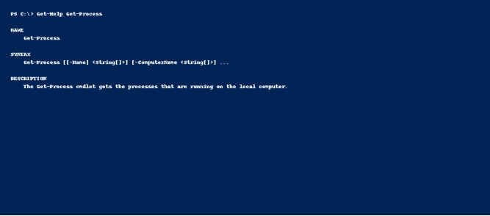WMI & PowerShell

|  |
| --- |
|  |
|  | C:\Users\LENOVO\AppData\Local\Temp\ksohtml3152\wps4.jpg |

Pipeline Filtering & Operators

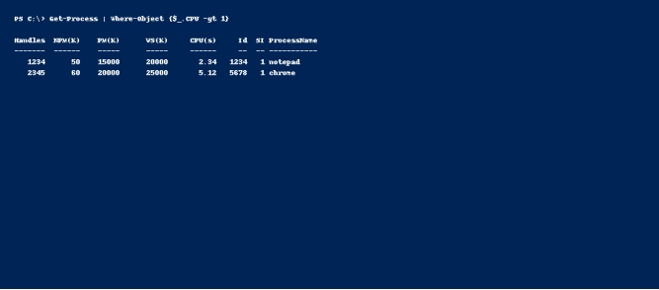

Input, Output & Formatting

|  |
| --- |
|  |
|  | C:\Users\LENOVO\AppData\Local\Temp\ksohtml3152\wps6.jpg |

Scripting Overview

